119K Commission Press Kit – Wednesday, March 6th at 11am – Capitol Building, North Lobby
CONTACT:
Donna Hamzy Carroccia
(203) 843-0705
dhamzy@ccm-ct.org

Commission Website
119Kcommission.org
Commission Members
- Josh Brown, Co-Chair, Domus
- Elinor Carbone, Co-Chair, Mayor, City of Torrington
- Andrew Ferguson, Co-Chair, Co-CEO, Dalio Education
- Arunan Arulampalam, Mayor, City of Hartford
- Joseph DeLong, Executive Director and CEO, CCM
- Justin Elicker, Mayor, City of New Haven
- Ben Florsheim, Mayor, City of Middletown
- Danielle Chesebrough, First Selectwoman, Town of Stonington
- Mike Freda, First Selectman, Town of North Haven
- Laura Hoydick, Mayor, Town of Stratford
- Chris Lippke, First Selectman, Town of Canterbury
- Mike Passero, Mayor, City of New London
- Caroline Simmons, Mayor, City of Stamford
- Erin Stewart, Mayor, City of New Britain
- Danielle Wong, Mayor, Town of Bloomfield

Statements from Co-Chairs and Committee Members
“In the face of Connecticut’s crisis on disconnected youth, I am eager to embark on this work alongside my fellow Commission members with the belief that change begins when we empower every young person with the tools to build their own future.” Elinor Carbone, Co-Chair, Mayor of Torrington
“I know from my lived and work experience that Connecticut’s challenge with disconnected youth demands a collective effort. As a community we can begin to make change by investing in education, mentorship, and by creating public private partnerships creating workforce pathways that lead to meaningful opportunities for these young people.” Josh Brown, Co-Chair
“To address Connecticut’s statewide crisis, we must recognize our systems are not serving all young people well. We must have the will to transform them; system change is not just a necessity but a promise to every young person that their potential matters.” Andrew Ferguson, Co-Chair
“Connecticut’s crisis on disconnected youth demands a united front. The mission of the CCM’s 119K Commission is to forge a path forward; a statewide strategy to guide us towards a brighter future for every young person.” Joseph DeLong, Executive Director and CEO of CCM

“CCM’s 119K Commission will seek to tackle the challenge of disconnected youth in Connecticut through the creation of a statewide strategy that engages members of the public and experts. This strategy will not just be a tool for change, but an essential framework to systematically address and overcome this crisis.” Erin Stewart, Mayor of New Britain

“To create lasting impact, CCM’s 119K Commission is championing the cause of disconnected youth in Connecticut by saying, ‘Now is the moment for a statewide strategy, a collaborative force that paves the way for comprehensive solutions.’” Arunan Arulampalam, Mayor of Hartford

"Investing in our disconnected youth is an investment in Connecticut's future – a future where every young person has the opportunity to thrive and contribute to the prosperity of our state." Justin Elicker, Mayor, City of New Haven

"Connecticut's youth are the architects of our future. A statewide strategy provides the blueprint to dismantle barriers, creating an environment where all young people can thrive, innovate, and contribute meaningfully to our communities. Danielle Chesebrough, First Selectwoman, Town of Stonington

"By developing a comprehensive statewide strategy, we can bridge the gaps that leave our youth disconnected, ensuring they have access to education, employment, and supportive services that pave the way for a brighter tomorrow." Ben Florsheim, Mayor, City of Middletown

"Connecticut's strength lies in its communities, and a cohesive strategy will empower us to build a network of support, mentoring, and resources for disconnected youth, fostering resilience and unlocking their full potential." Mike Freda, First Selectman, Town of North Haven

"A statewide approach is essential to break down systemic barriers and create pathways for success, allowing every young person to connect to the opportunities that will shape their lives and, in turn, strengthen our communities." Laura Hoydick, Mayor, Town of Stratford

"Tackling the crisis of disconnected youth requires collaboration across sectors – government, education, businesses, and nonprofits – to create a unified strategy that addresses the unique needs of our youth and ensures no one is left behind." Chris Lippke, First Selectman, Town of Canterbury

"Connecticut's future success hinges on our ability to re-engage disconnected youth; a well-crafted statewide strategy will empower us to build a more inclusive and equitable society for generations to come." Mike Passero, Mayor, City of New London

"Our commitment to a statewide strategy signifies a dedication to the well-being and potential of every young person in Connecticut, fostering a sense of belonging and purpose that transcends socioeconomic challenges." Caroline Simmons, Mayor, City of Stamford

"Addressing the crisis of disconnected youth demands a comprehensive and compassionate approach. A statewide strategy will serve as a roadmap to connect, empower, and uplift our youth, paving the way for a stronger, more resilient state." Danielle Wong, Mayor, Town of Bloomfield

Social Media
#119Kcommission
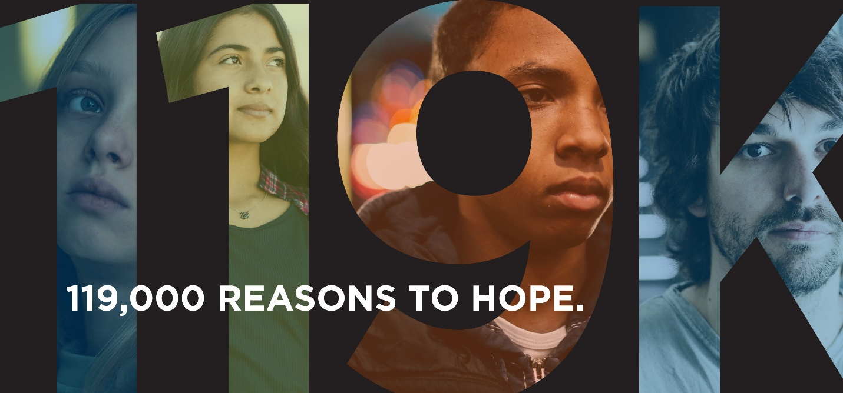

Article/Press Links
The Dalio Report
CT Insider https://www.ctinsider.com/news/article/dalio-report-disconnected-youth-18389276.php
WTNH https://www.wtnh.com/news/connecticut/report-120k-connecticut-students-considered-at-risk/
NBC Connecticut https://www.nbcconnecticut.com/investigations/disconnected-foundation-says-ct-youth-are-in-danger-of-not-becoming-self-sufficient/3122078/
CT Post https://www.ctpost.com/opinion/article/nearly-one-five-ct-young-people-lack-societal-18419554.php
Fox 61 https://www.fox61.com/article/news/education/connecticuts-unspoken-crisis-report-19-youth-disconnected-education-employment/520-6415b458-4b02-4b14-9e26-788aab6bb360
WSHU https://www.wshu.org/connecticut-news/2023-10-12/connecticut-youth-disconnected-education-employment
Ready CT https://readyct.org/2023/10/statement-from-shannon-marimon-regarding-the-2023-dalio-education-report-connecticuts-unspoken-crisis-getting-young-people-back-on-track/
Inside Investigator https://insideinvestigator.org/report-identifies-119000-disconnected-connecticut-students/
The CCM Roundtables
Courant https://www.courant.com/2023/10/25/a-costly-crisis-119000-ct-teens-are-unemployed-unemployable-or-on-their-way/
CT News Junkie https://ctnewsjunkie.com/2023/10/25/dalio-education-report-highlights-connecticuts-invisible-youth-crisis-calls-for-awareness-and-action/
CT News Junkie https://ctnewsjunkie.com/2023/10/27/panelists-young-people-need-more-support-and-earlier/
CT Public https://www.ctpublic.org/show/disrupted/2023-12-20/connecticuts-young-people-on-the-states-unspoken-crisis?fbclid=IwAR1OBP1WaQP2E4bE-D4wvu_A0UK95v0qQUS0bzZvUHgDShG0fZbhekDlpMU
CT News Junkie https://ctnewsjunkie.com/2023/10/25/op-ed-dalio-report-should-spark-a-bipartisan-conversation/
CCM Roundtables – LIVE Recordings
- CCM Fireside Chat – November 28
- Joe Delong, CCM Executive Director and CEO, speech at 2023 Convention and Annual Meeting
- CCM Regional Roundtable Livestreams
  - Norwalk – October 19
  - Wethersfield – October 24
  - Torrington – October 26
  - Middletown – November 13
  - Windham – November 1

